**Leading teams - Effective Communication and Collaboration**

### Leading Teams: Fostering Effective Communication and Collaboration (SkillSoft Professional)

WBT ITM_1009253

**Characteristics of healthy team communication**

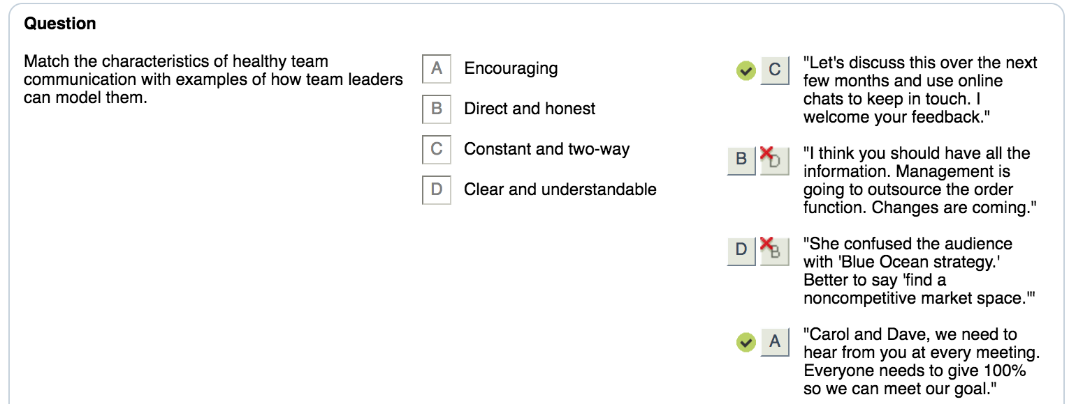

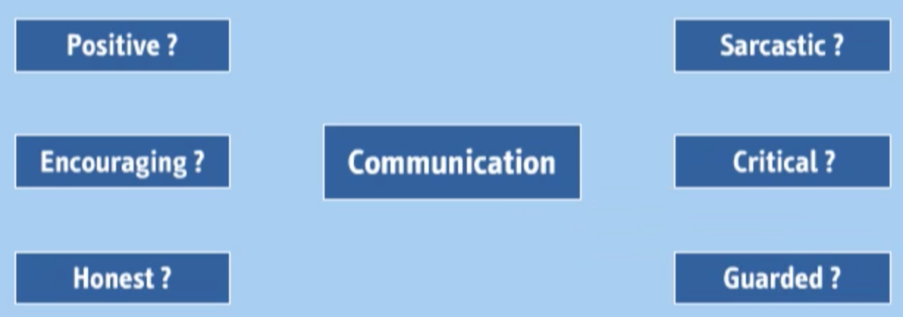

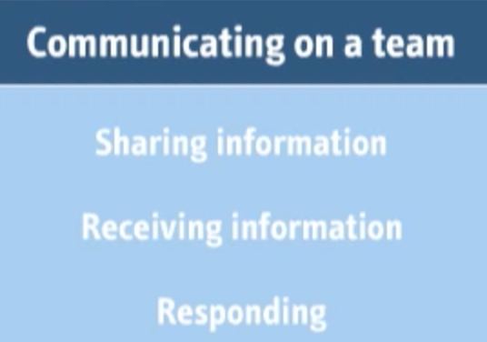

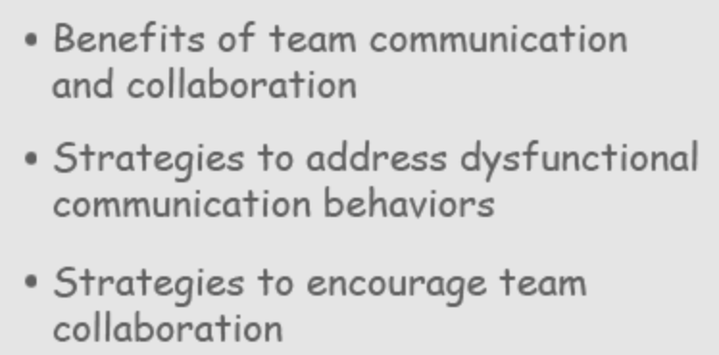

**Importance of good communication**

**Healthy communication**

**Team value**

**Lead by example**

**Characteristics of Healthy Team communication**

**Direct, honest and concise**

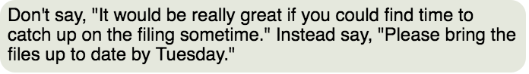

**Clear, understandable and precise**

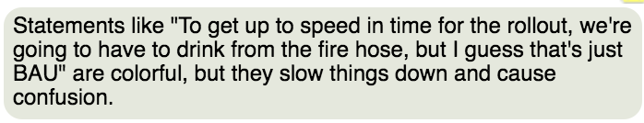

**Two-way street – give each other positive and negative feedback**

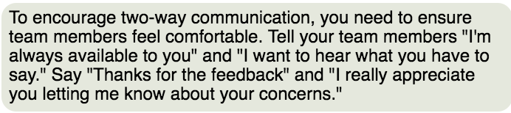

**Encouraging everyone to participate**

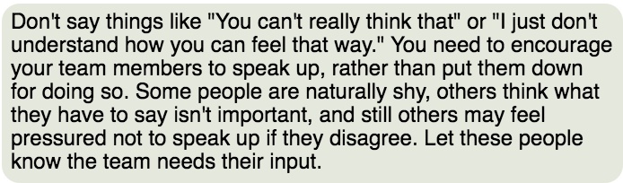

**Constance flow – information is shared in a timely fashion**

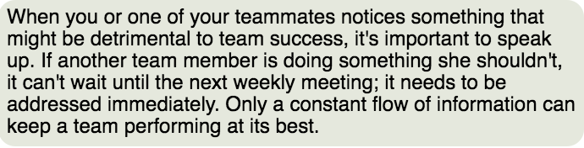

-=-=-=-=-=-=-=-=-=

# **Recognizing Healthy Team Communication**

**Purpose:** Use this job aid when trying to encourage healthy communication on your team.

Teams with a healthy approach to communication exhibit five main characteristics.

### Direct, honest, and concise

Communication is direct, honest, and concise. When you and your team members communicate, describe the action you want taken and give all the necessary information.

#### Examples of what to say:

* "Please finish the report by close of business on Friday."
* "I need you to submit your project plans and ensure they're error free by Tuesday at 3 p.m."
* "Here's the situation. The executive committee is requiring full compliance by December 1 or the project will be scrapped."
* "I think it's only fair that you know everything. Management is planning on shutting down two of the satellite offices and reducing the staff at the home office by 20%."

### Clear, understandable, and precise

Team communication must be clear, precise, and understandable. Avoid using jargon, slang, abbreviations, or acronyms that aren't immediately recognizable to everyone on the team.

#### Examples of what to say:

* Say "The application service provider used a system where what comes in last is handled first" instead of "The ASP's system was LIFO."
* Say "The chief information officer wants the computer-aided design by 5 p.m. Friday" rather than "The CIO wants the CAD completed by COB Friday."

### Two-way

Healthy communication is a two-way street. On healthy teams, the team leader and team members exchange information and feel free to give each other positive and negative feedback.

#### Examples of what to say:

* "I'm always available after office hours by e-mail or phone."
* "I'm really glad to get your viewpoint."
* "Thanks for telling me about your concerns."
* "I appreciate you giving me such timely feedback."
* "Thanks for pointing out that I forgot to include the glossary."

### Encouraging

You need to encourage your teammates to express their views and show you value their comments and suggestions. You need to ensure all team members feel comfortable and ready to participate. You never know where a great idea will come from, and everyone must be ready to contribute.

#### Examples of what to say:

* "Your input is important."
* "The team needs everyone's opinion."
* "You hardly said a thing at the meeting. I'd like to hear more about what you think of this project."
* "We were selected for this team because we each have experience in different areas. Sharing our knowledge is our greatest strength."
* "Your last proposal was great. Let's hear what you've come up with so far on this one. We need your input."

### Constant

Constant communication ensures that information is exchanged in a timely fashion. By keeping the lines of communication open and flowing, mistakes are caught early and potential conflicts can be headed off.

#### Examples of what to do:

* Jim e-mails his team members daily about deadlines and asks for status on their progress.
* Jamal makes sure his department's telephone budget allows his remote team members to pick up the phone whenever they need to talk with him or another team member. Team members take advantage of this regularly.
* Kim's team members are constantly brainstorming about solutions to problems they encounter.
* Gabrielle's team members know that if any of them receives feedback from a customer, they immediately communicate it to the rest of the team. If the news is serious, they hold a team meeting right away to discuss the issue.

**Course:** Leading Teams: Fostering Effective Communication and Collaboration  
**Topic:** Qualities of Good Team Communication

-=-=-=-=-=-==--=-=-=

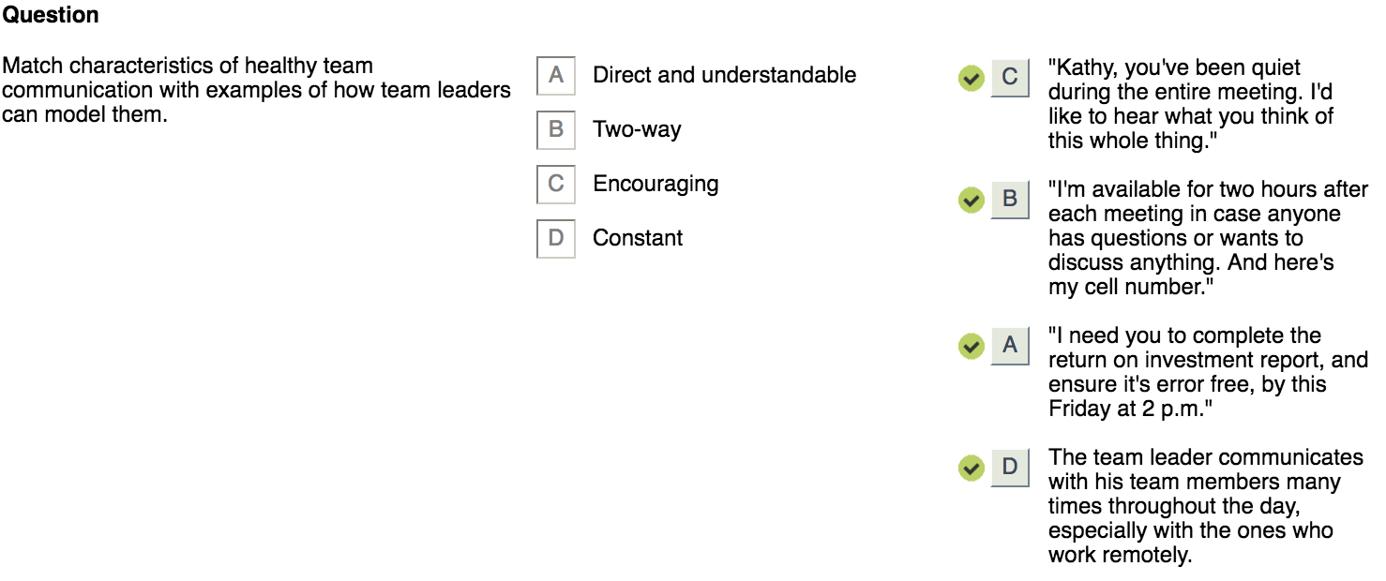

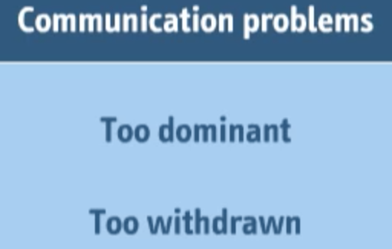

Dominant

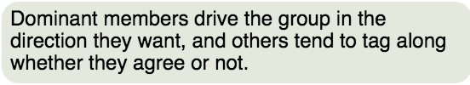

Withdrawn

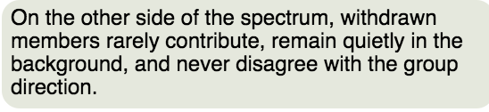

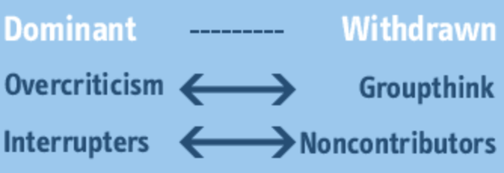

Over-criticism

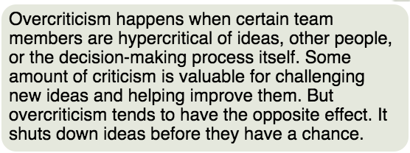

Groupthink

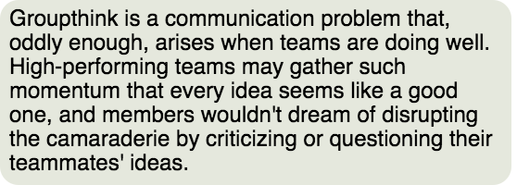

Interrupters

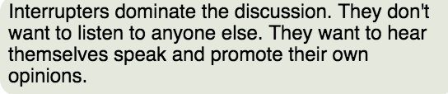

Noncontributors

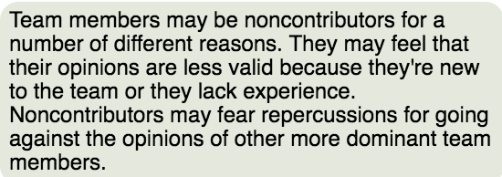

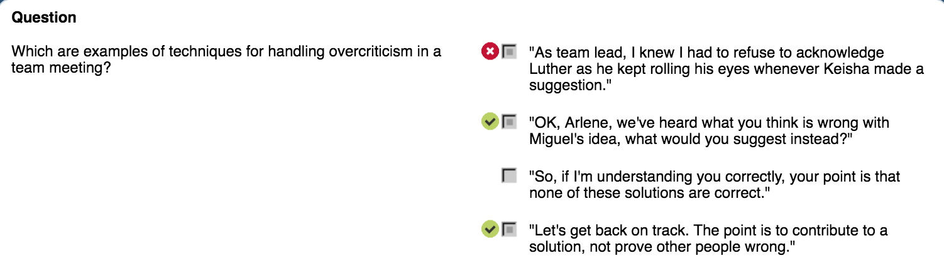

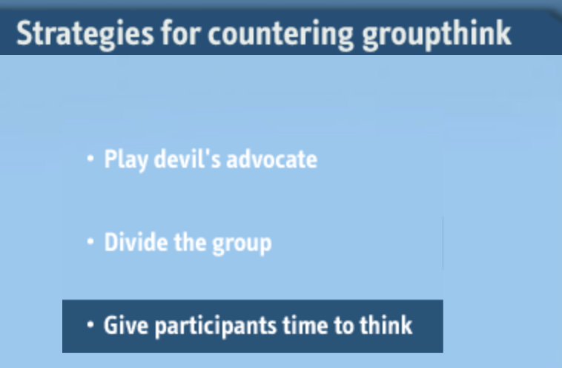

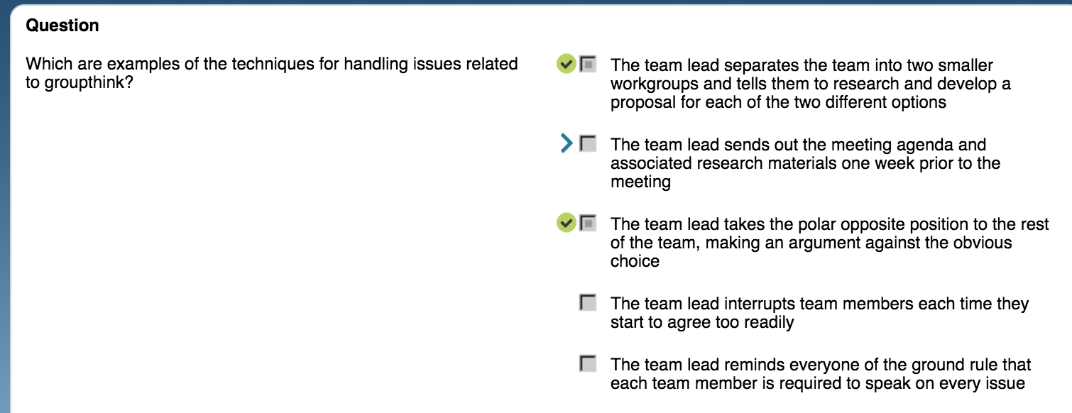

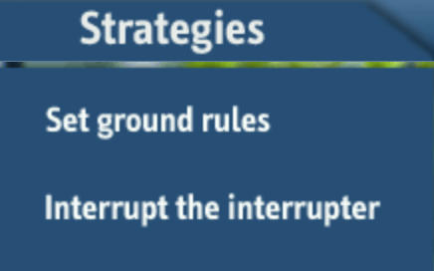

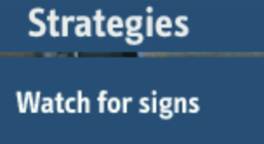

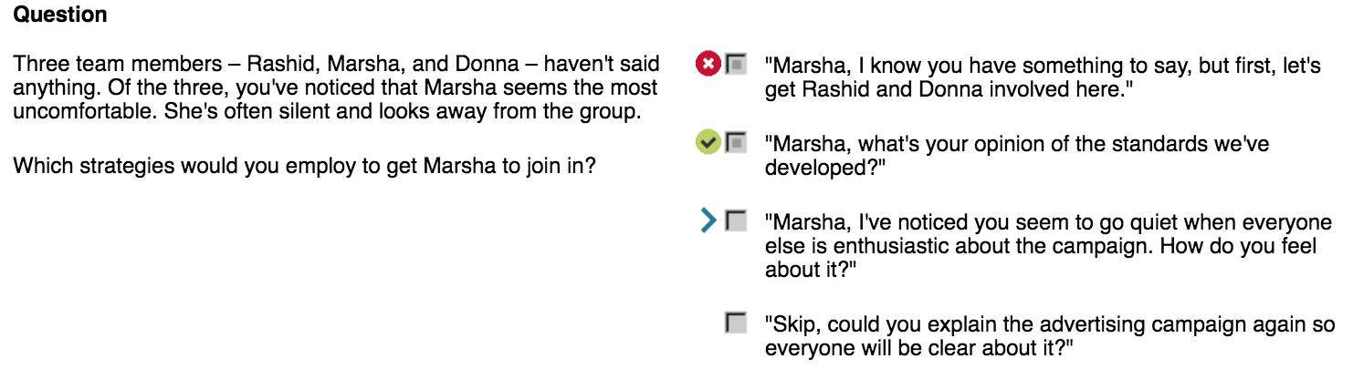

-=-==--=-=-=-=-==-

# **Strategies for Handling Communication Problems**

**Purpose:** Use this job aid as a reminder of the appropriate strategies to employ for the various types of dysfunctional communication behaviors found in team meetings.

## Dysfunctional Communication Behaviors in Team Meetings

### Overcriticism

Team members are hypercritical of ideas, other people, or the decision-making process itself. Overcriticism shuts down ideas before they have a chance to develop and negatively affects team relationships.

#### Strategies to address overcriticism:

* Immediately say or do something to regain control over the meeting.
* Ask the overly critical person what her suggestion or solution might be.
* To strategically get the team back on track, refocus efforts on solutions, not criticism.

### Groupthink

Team members undercriticize teammates when a team is in groupthink. Single solutions are all that the team seeks and agreement is quick. Team members who disagree remain silent for fear of disturbing the momentum and positive feelings the team has achieved.

#### Strategies to address groupthink:

* Play devil's advocate. Challenge the group opinion – even if you agree with it – to encourage some critical thinking.
* Divide the group into subgroups to break up the existing social patterns and power structures within the team.
* Give meeting participants time to think through ideas on their own, by distributing meeting agendas and materials in advance.

### Interrupters

Dominant team members tend to interrupt others and, once they take control of the conversation, are reluctant to give it up.

#### Strategies to address interrupters:

* Establish rules of order and remind members of these ground rules periodically.
* Interrupt the interrupter and give the floor back to the person who was cut off.

### Noncontributors

The environment may seem unsafe to some members. Some noncontributors may have nothing to say about a particular issue, but others may have a lot to contribute and may need drawing out.

#### Strategies to address noncontributors:

* By moderating the dominant team members, you can create a safer environment where silent team members can begin speaking up.
* Watch for signs that a team member wants to speak. Be alert to both verbal and nonverbal cues. Then, cut into the discussion and give that person the floor.
* If you have created a safe environment and you still have some nonparticipants, encourage them to speak by directly asking for their input.

**Course:** Leading Teams: Fostering Effective Communication and Collaboration  
**Topic:** Handling Communication Problems in Team Meetings

-=-=-=-=-=-=-=-=-=-=

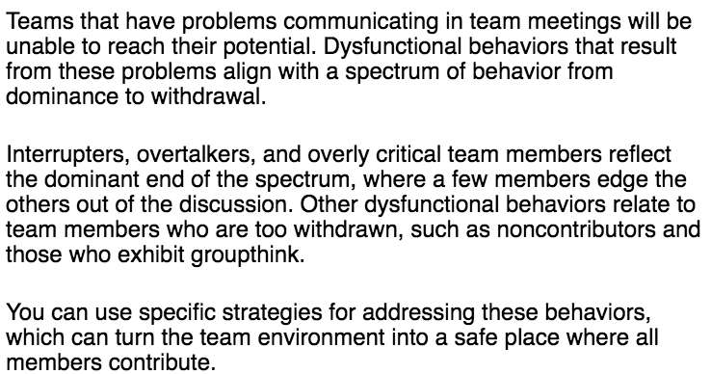

-=-=-=-=-=

Unfettered competition

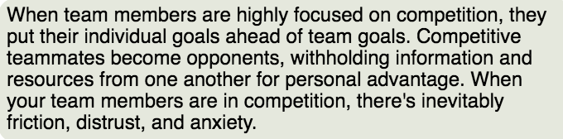

Super-collaboration

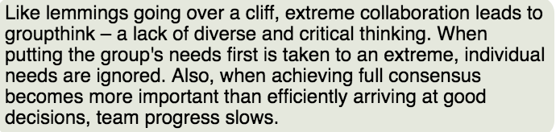

**To achieve a balance**

* Reward ambition
* Emphasize process to achieve team goals

**Team oriented messages**

* Context and motivation to work as teams
* Get beyond personality differences

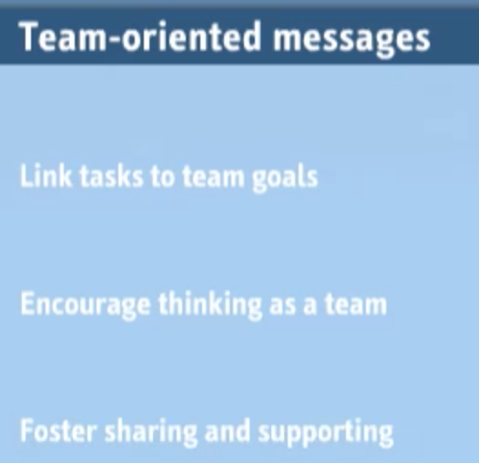

Link tasks to team goals

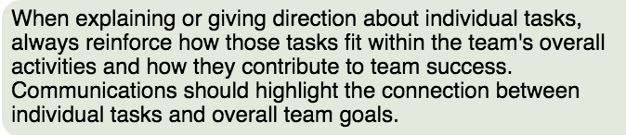

Encourage thinking as a team

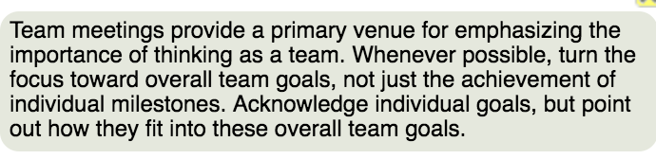

Foster sharing and supporting

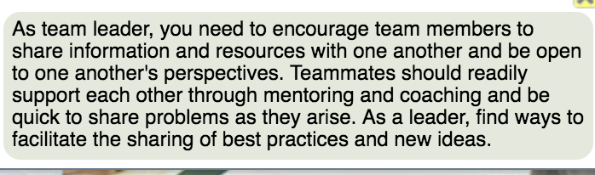

**Team oriented assignments**

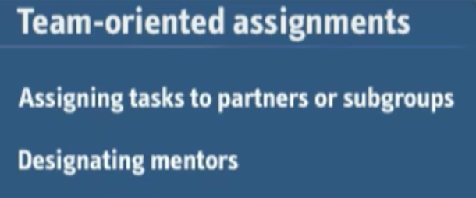

Assign tasks to partners or subgroups

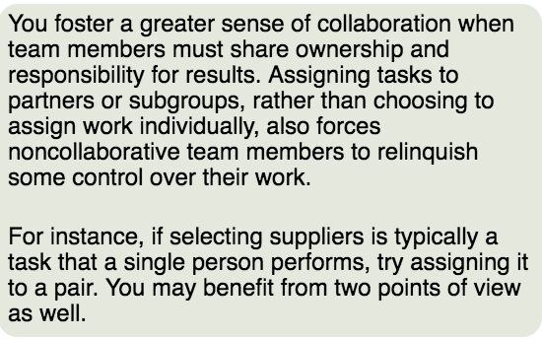

Designating mentors

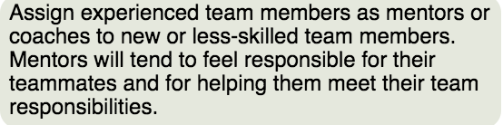

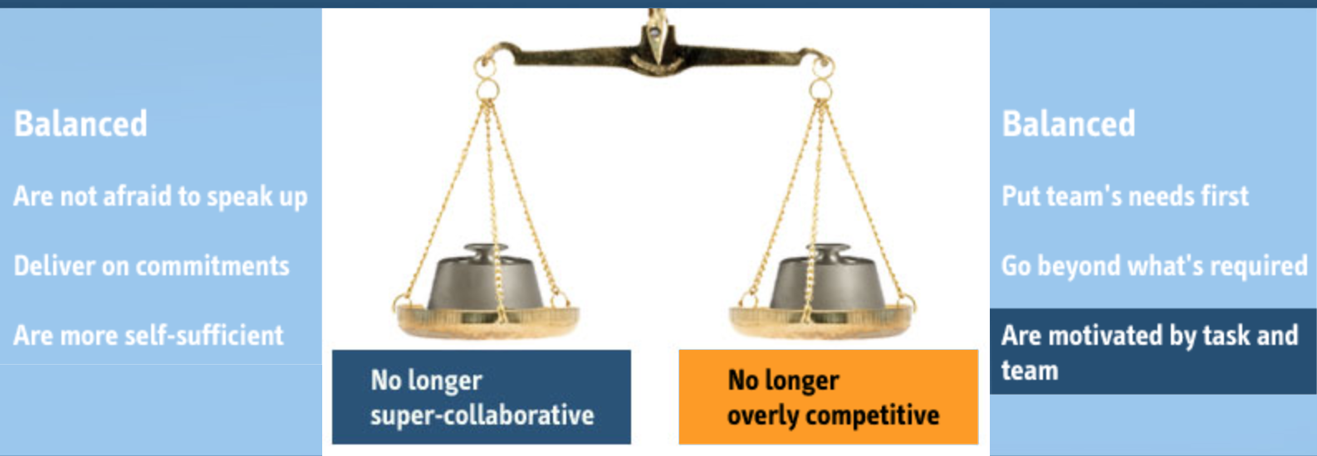

# **Competition or Collaboration**

**Purpose:** Use this follow-on activity to assess your current team in relation to amounts of competition and collaboration.

**Instructions for use:** Using the questions provided as a starting point to consider your current team, evaluate levels of collaboration and competition, and target areas for improvement.

#### Super-collaboration

* Do team members always try to reach consensus on every issue?
* Is decision making very slow and inefficient?
* Do members always tend to agree?
* Are members aware of their individual responsibilities?
* Do they take responsibility for their own mistakes?
* Are members fearless about speaking up to ensure the team's needs are met?
* Do they argue points thoroughly?
* Do they question authority when it would be appropriate to?

#### Competition

* Do team members tend to have contests with one another?
* Do they withhold information from one another?
* Is there an atmosphere of distrust in team meetings?
* Do members put personal advancement first and the team's needs second?
* Do members spend time blaming others rather than moving past problems?
* Are members more focused on hitting metrics than on the quality of the team's work and interactions?

List the problem areas you've identified:  
  
1.

2.

3.

4.

5.

6.  
  
List your plans for addressing the problem areas:  
  
1.

2.

3.

4.

5.

6.

-==--=-=-=-=-=-=-=-==-